# **Programming Assignment Unit 4**

Computer Science, University of the People

CS 2203-01 Databases 1 - AY2024-T3

Instructor, Irfan Rashid Thoker

February 27, 2024

## Normalizing our hospital system

For this assignment, we are tasked with continuing our work on the hospital data structure, this time focusing on normalizing our structure through all the stages of normalization.

**Step 1 – 1NF – First normal form:**

For us to reach the first level we will need to do and complete the following:

* The values in every column must be atomic, meaning they are indivisible.
* Every column must have values of only a single data type.
* The columns must have unique and meaningful names

**The changes we need to make to achieve 1NF are:**

* **Patients**: the column “allergies” could and might contain a list of the patient's allergens. Meaning that this would be non-atomic. To resolve this we need to separate the allergies to a new table with a foreign key connecting back to the patient table.
* **Appointment**: much the same here we have a column called “Medicines” which can represent a list of medicines the patient was given during the appointment. This too needs to be split off and moved into a table of its own with a foreign key pointing back.

After these changes, we will have the following:

* Doctor
  + DOCTOR_ID (PK)
  + NAME
  + PHONE
  + SPECIALTY_NUMBER
  + SPECIALTY
* Patient
  + PATIENT_ID (PK)
  + NAME
  + PHONE
  + EMAIL
  + ADDRESS
  + DATE_ADDED
  + DOCTOR_ID (FK)
* PatientAllergies
  + PATIENT_ID (FK)
  + ALLERGY
* Appointment
  + APPOINTMENT_ID (PK)
  + APPOINTMENT_DATE
  + DOCTOR_ID (FK)
  + PATIENT_ID (FK)
  + BLOOD_PRESSURE
  + PULSE
  + TREATMENT_NOTES
* AppointmentMedicines
  + APPOINTMENT_ID (FK)
  + MEDICINE

**Step 2 – 2NF – Second normal form:**

For us to reach the next level we will need to do and complete the following on top of the first level:

* All non-key attributes must be fully functional and dependent on the primary key.

**The changes we need to make to achieve 2NF are:**

* **Doctor Table**: Already in 2NF.
* **Patient Table**: Already in 2NF after 1NF adjustments.
* **PatientAllergies**: This table is in 2NF.
* **Appointment Table**: Already in 2NF after 1NF adjustments.
* **AppointmentMedicines**: This table is in 2NF.

**Step 3 – 3NF – Third normal form**

For us to reach the next level we will need to do and complete the following on top of the first and second levels:

* All the attributes must be dependent on the primary key and not on any other non-key attribute.

**The changes we need to make to achieve 3NF are:**

1. **Doctor Table**: We can split SPECIALTY_NUMBER and SPECIALTY into a new table since specialty can be considered an independent entity. This will result in the following additional changes:

* Specialty
  + SPECIALTY_NUMBER (PK)
  + SPECIALTY
* Doctor
  + DOCTOR_ID (PK)
  + NAME
  + PHONE
  + SPECIALTY_NUMBER (FK)

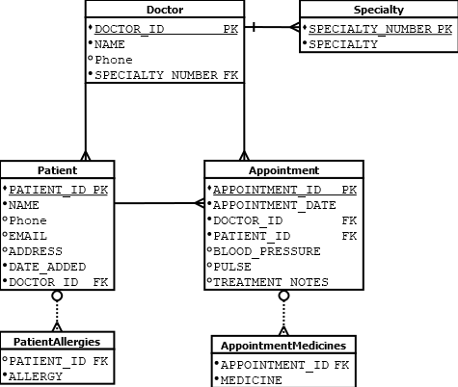The following is a revised E-R diagram which includes all the normalization changes

## References

* Programming Assignment Unit 1-2
* Learning Guide Unit 1-4
* Sharma, N., Perniu, L., Chong, R. F., Iyer, A., Nandan, C., Mitea, A. C., Nonvinkere, M. & Danubianu, M. (2010). Database fundamentals. IBM Canada.  
  <https://my.uopeople.edu/pluginfile.php/1827130/mod_book/chapter/484065/Database_Fundamentals.pdf>
* Watt, A., & Eng, N. (2014). Database design,  2nd ed. BCcampus, BC Open Textbook Project.   
  <https://opentextbc.ca/dbdesign01/>  
  <https://my.uopeople.edu/pluginfile.php/1827130/mod_book/chapter/484065/Database-Design-2nd-Edition-1560272109.pdf>